SQL

Given the following tables, write a query which returns the total footfall count per premises. The resultset should contain the following non-null columns: Business, StreetNo, Street, PostCode, FootfallCount. Premises do not necessarily have footfall for every week (missing counts should have a count of zero). Missing street numbers will be replaced with empty string ''.

Query performance must not be affected by transactions which are running at the same time.

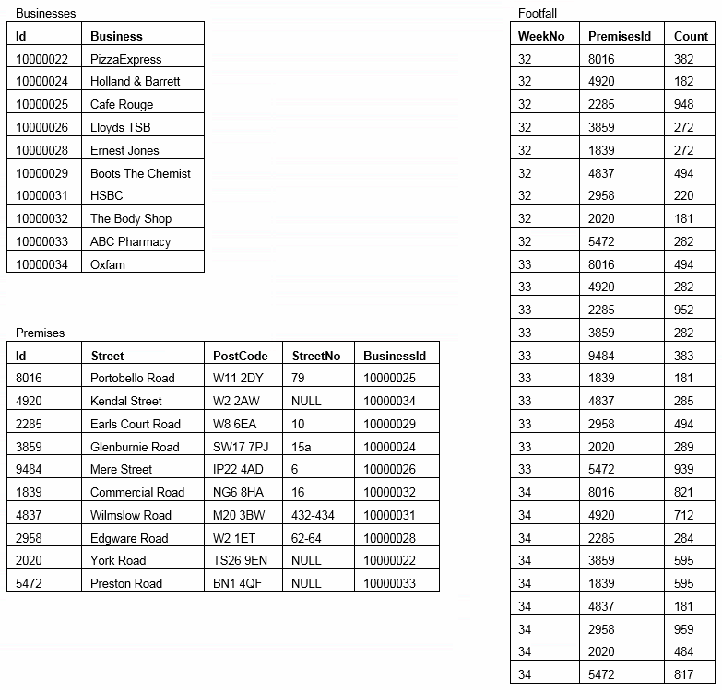

C#

Write C# code with unit-tests to process a collection of string values which are passed to a method which returns a collection of processed strings. The input strings may be any length and can contain any character. Output strings must not be null or empty string, should be truncated to max length of 15 chars, and contiguous duplicate characters in the same case should be reduced to a single character in the same case. Dollar sign ($) should be replaced with a pound sign (£), and underscores (_) and number 4 should be removed. Code should be test-driven, efficient, re-usable and loosely coupled. The returned collection must not be null.

Example input string: AAAc91%cWwWkLq$1ci3_848v3d__K

To circumvent common issues with physically transferring oft-banned file types – e.g. sending via email – the solution should be available within a Git repository (i.e. GitHub or similar) and the necessary repo URL provided for LDC to access upon completion of the tasks.